Amazon A2I – Amazon Augmented AI
Amazon Augmented AI (A2I) is a managed service from Amazon Web Services that enables human-in-the-loop machine learning. It allows you to automatically route uncertain or sensitive predictions from ML models to human reviewers for validation and correction.
A2I works by integrating with ML services such as Amazon Textract, Amazon Rekognition, or custom models built using Amazon SageMaker. When a model produces a result, A2I evaluates it based on predefined conditions (like low confidence scores or specific business rules). If the condition is met, the task is sent to a human review workflow, where reviewers verify or correct the output. The final validated result is then returned.
The service provides prebuilt workflows for common tasks (e.g., text extraction, content moderation) and also supports custom workflows tailored to specific applications. It offers flexibility in choosing the workforce, including private teams, third-party vendors, or crowd workers.
The main advantages of A2I are improved accuracy, better compliance in critical applications, and reduced effort in building manual review systems. It is widely used in areas like document processing, content moderation, and industries requiring high reliability such as finance and healthcare.
In short: A2I enhances machine learning systems by combining automated predictions with human judgment to ensure more accurate and trustworthy results.
How It Works
A2I uses a HumanLoop to manage the process:
- Prediction: An ML model makes a prediction.
- Evaluation: A2I evaluates if the prediction meets a set confidence threshold.
- Human Review: If the confidence is low, the data is sent to a human worker, who uses a web interface generated by A2I.
- Consolidation: The human-reviewed result is sent to the output destination
Key Features & Benefits
- Built-in Workflows: Provides pre-built human review templates for common use cases like document processing, image moderation, and text extraction.
- Confidence Thresholds: Automatically routes low-confidence predictions to human reviewers, reducing unnecessary manual review.
- Flexible Workforce: Allows use of internal employees, third-party vendors, or the public Amazon Mechanical Turk marketplace.
- Integration: Works with Amazon SageMaker, Amazon Rekognition, Amazon Textract, and custom models.
Use Cases
- Document Processing: Verifying PII (Personally Identifiable Information) redaction or extracting data from forms.
- Content Moderation: Reviewing images or text for inappropriate content.
- Compliance & Accuracy: Ensuring high-stakes decisions in finance or healthcare meet accuracy standards

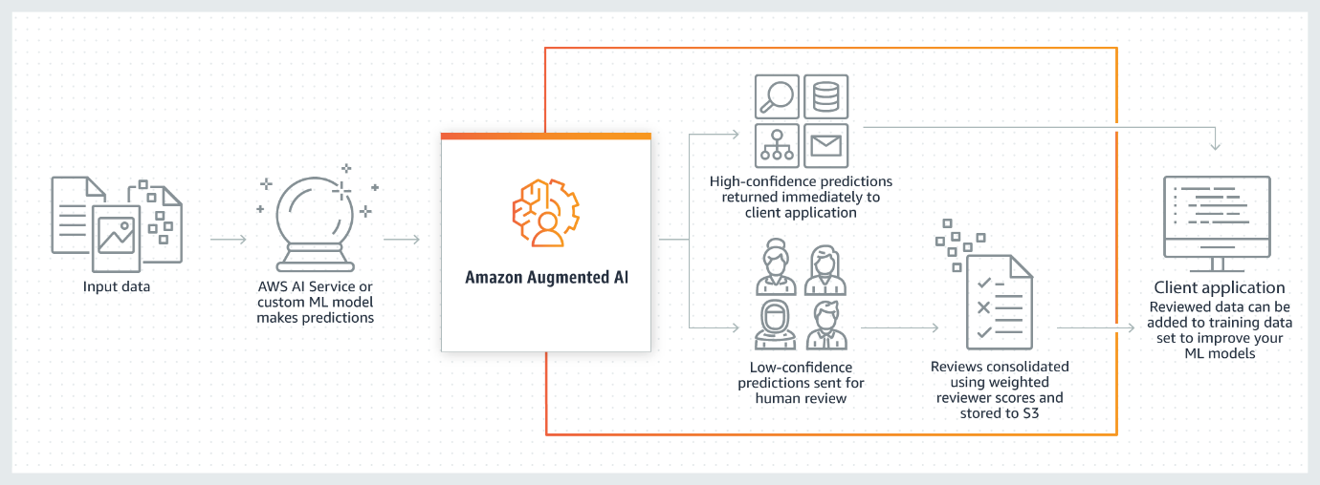
What is Amazon Augmented AI?
Amazon Augmented AI (Amazon A2I) is a service that brings human review of ML predictions to all developers by removing the heavy lifting associated with building human review systems or managing large numbers of human reviewers.
Many ML applications require humans to review low-confidence predictions to ensure the results are correct. For example, extracting information from scanned mortgage application forms can require human review due to low-quality scans or poor handwriting. Building human review systems can be time-consuming and expensive because it involves implementing complex processes or workflows, writing custom software to manage review tasks and results, and managing large groups of reviewers.
Amazon A2I streamlines building and managing human reviews for ML applications. Amazon A2I provides built-in human review workflows for common ML use cases, such as content moderation and text extraction from documents. You can also create your own workflows for ML models built on SageMaker AI or any other tools. Using Amazon A2I, you can allow human reviewers to step in when a model is unable to make a high-confidence prediction or to audit its predictions on an ongoing basis.
Amazon A2I Use Case Examples
The following examples demonstrate how you can use Amazon A2I to integrate a human review loop into your ML application. For each of these examples, you can find a Jupyter Notebook that demonstrates that workflow in Use Cases and Examples Using Amazon A2I.
- Use Amazon A2I with Amazon Textract – Have humans review important key-value pairs in single-page documents or have Amazon Textract randomly sample and send documents from your dataset to humans for review.
- Use Amazon A2I with Amazon Rekognition – Have humans review unsafe images for explicit adult or violent content if Amazon Rekognition returns a low-confidence score, or have Amazon Rekognition randomly sample and send images from your dataset to humans for review.
- Use Amazon A2I to review real-time ML inferences – Use Amazon A2I to review real-time, low-confidence inferences made by a model deployed to a SageMaker AI hosted endpoint and incrementally train your model using Amazon A2I output data.
- Use Amazon A2I with Amazon Comprehend – Have humans review Amazon Comprehend inferences about text data such as sentiment analysis, text syntax, and entity detection.
- Use Amazon A2I with Amazon Transcribe – Have humans review Amazon Transcribe transcriptions of video or audio files. Use the results of transcription human review loops to create a custom vocabulary and improve future transcriptions of similar video or audio content.
- Use Amazon A2I with Amazon Translate – Have humans review low-confidence translations returned from Amazon Translate.
- Use Amazon A2I to review tabular data – Use Amazon A2I to integrate a human review loop into an ML application that uses tabular data.

Links:
- https://docs.aws.amazon.com/augmented-ai/#:~:text=Amazon%20Augmented%20AI%20(Amazon%20A2I,large%20numbers%20of%20human%20reviewers.
Amazon Transcribe

Speech to Text Service –
Automatically convert speech to text
What is Amazon Transcribe?
- Extract key business insights from customer calls, video files, clinical conversations, and more.
- Improve business outcomes with state of the art speech recognition models that are fully managed and continuously trained.
- Enhance accuracy with custom models that understand your domain specific vocabulary.
- Ensure customer privacy and safety by masking sensitive information.
- Missing alt text value

Use Cases
- Get Insights From Customer Conversations
- Search and Analyze Media Content
- Create Subtitles and Meeting Notes
- Improve Clinical Documentation

What is Amazon Transcribe?
Amazon Web Services Amazon Transcribe is a fully managed Automatic Speech Recognition (ASR) service that converts spoken audio into written text using deep learning models.
In simple terms:
It listens to speech (audio/video) and generates accurate text transcripts automatically, without manual typing.

Core Concept Behind It
Amazon Transcribe is based on Automatic Speech Recognition (ASR), which involves:
- Capturing audio signals
- Converting sound waves into digital features
- Applying deep learning models
- Producing text output
It continuously improves using machine learning models trained on large speech datasets.

How Amazon Transcribe Works (Step-by-Step)
Step 1: Input Audio
- Upload audio/video file (e.g., .mp3, .wav, .mp4)
- Usually stored in Amazon S3

Step 2: Processing
- Service analyzes:
  - Speech patterns
  - Language
  - Speaker changes

Step 3: Speech Recognition
- Converts audio → phonemes → words → sentences

Step 4: Output Generation
- Returns output in:
  - JSON (detailed structure)
  - TXT (plain text)
  - SRT/VTT (subtitles)

Key Features (Detailed)
1. Speech-to-Text Conversion
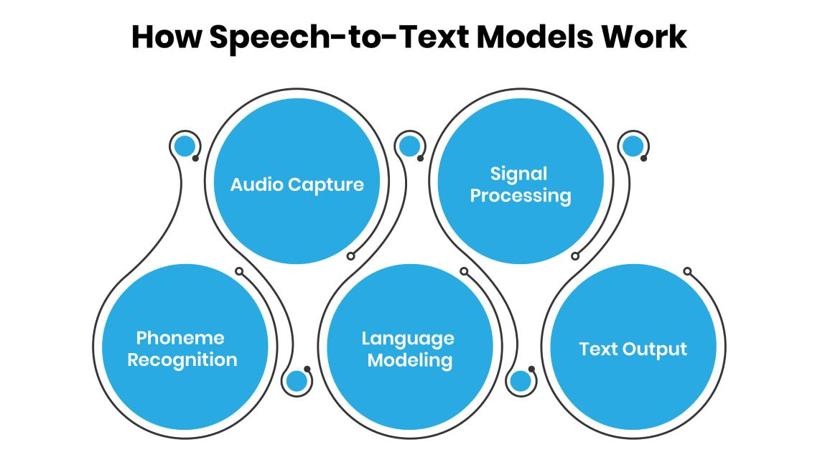
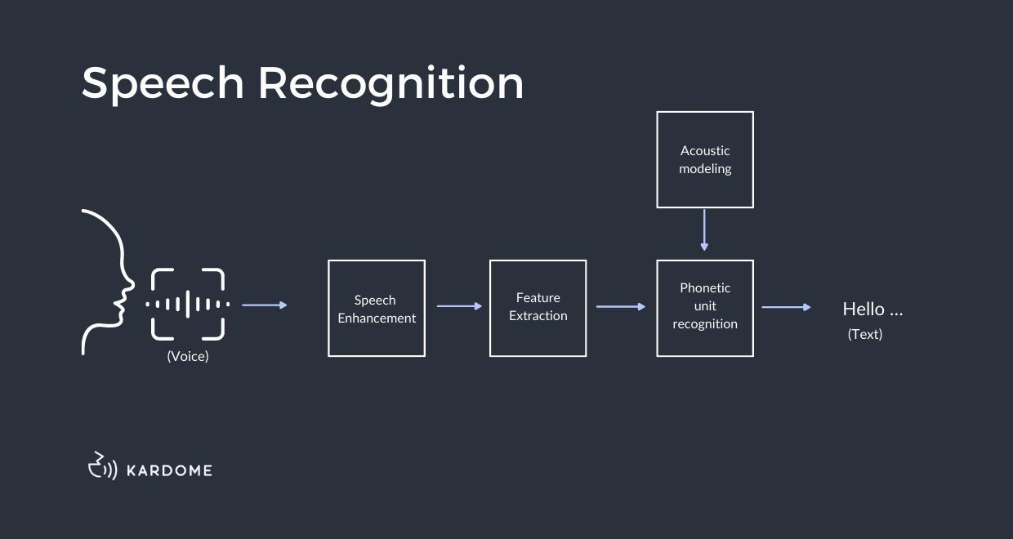
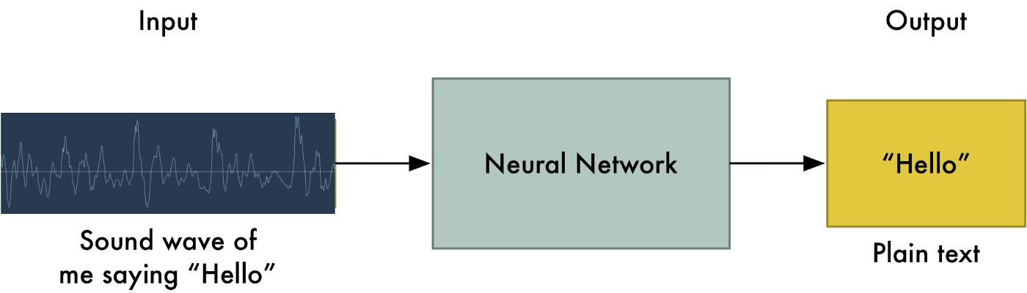
6
- Converts spoken language into written text
- Supports both clear and conversational speech

2. Real-Time Transcription (Streaming)
- Live transcription for:
  - Meetings
  - Live events
  - Customer calls
Example: Zoom-like captions in real time

3. Batch Transcription
- Upload file → process → get transcript later
- Best for:
  - Recorded lectures
  - Podcasts

4. Speaker Diarization (Speaker Identification)
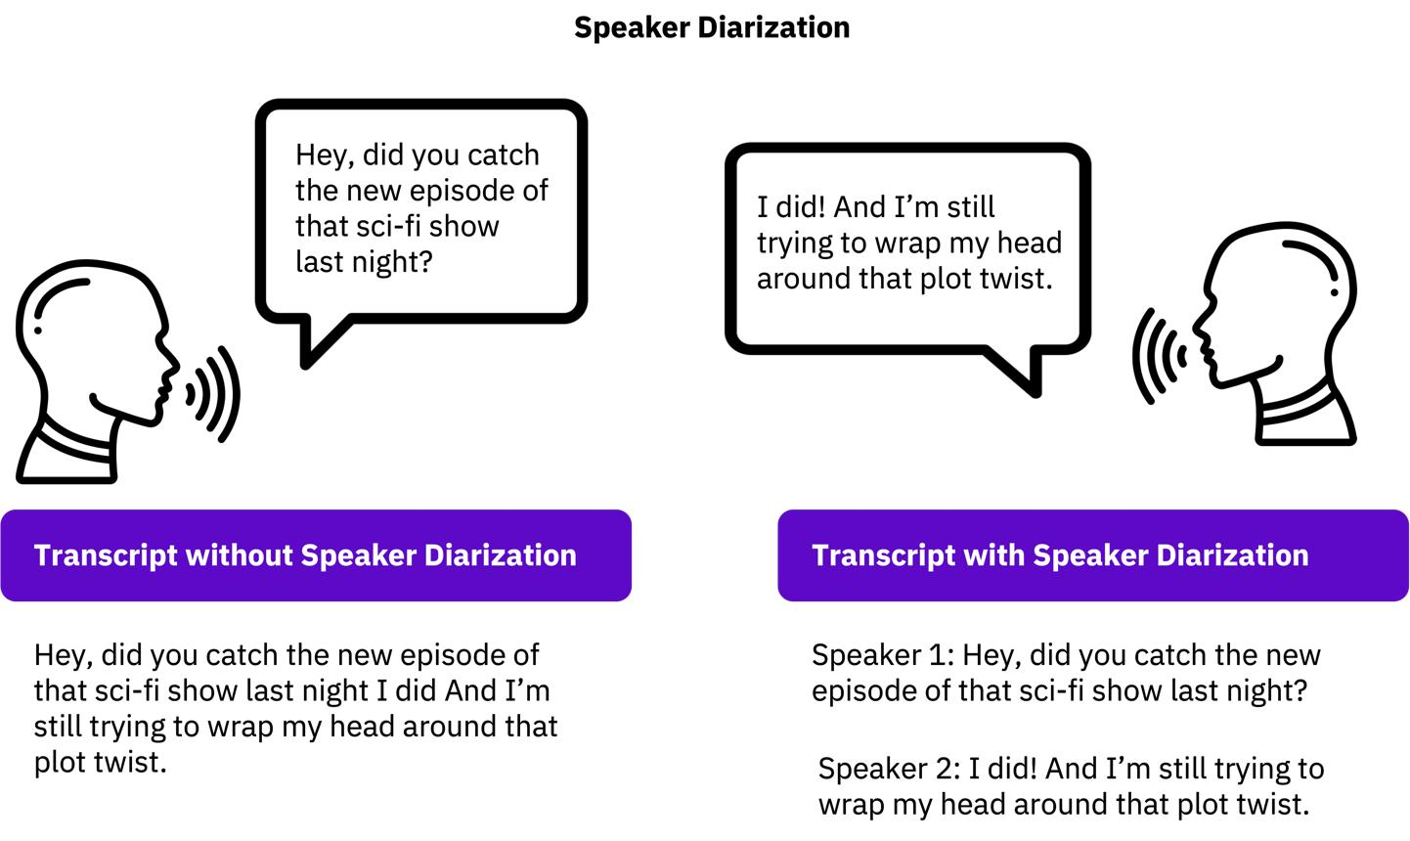
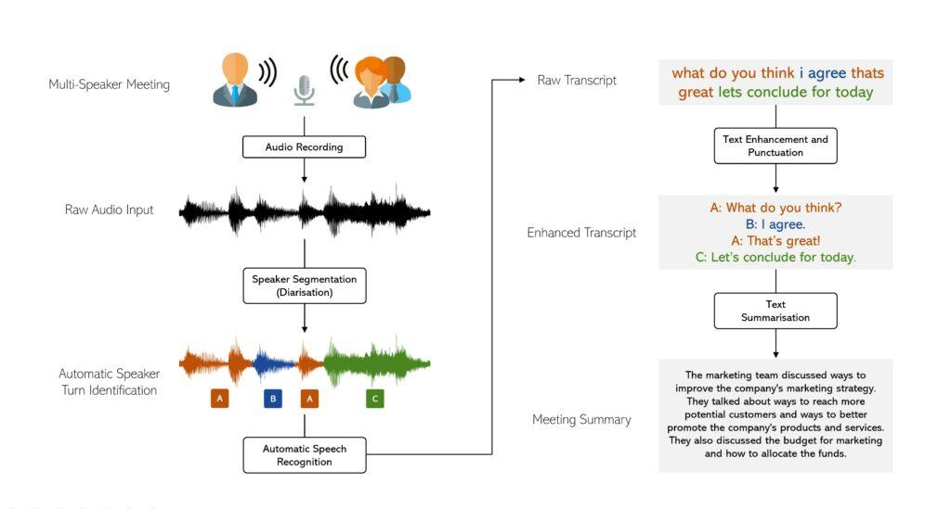
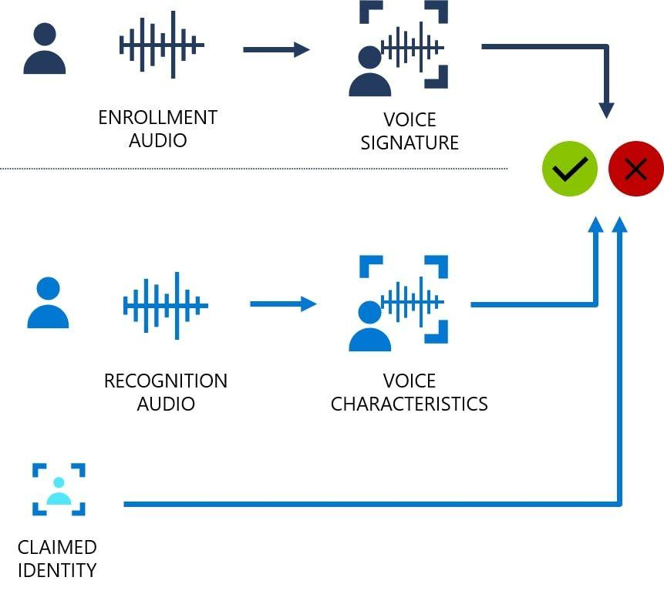
6
- Identifies multiple speakers
- Labels them as:
  - Speaker 1
  - Speaker 2
Useful in meetings & call centers

5. Language Support
- Supports multiple languages:
  - English (various accents)
  - Spanish, French, German, etc.
- Can detect dominant language automatically

6. 🧾 Custom Vocabulary
- Add domain-specific words:
  - Medical terms
  - Company names
Improves transcription accuracy significantly

7. Content Redaction (Security Feature)
- Automatically hides sensitive information:
  - Names
  - Phone numbers
  - Credit card details
Important for compliance & privacy

8. Call Analytics (Advanced Feature)
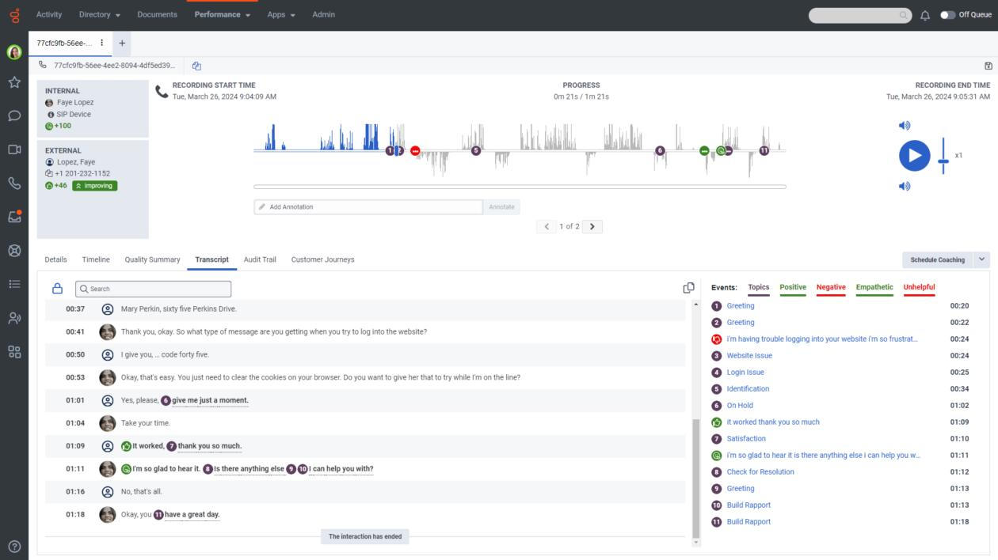
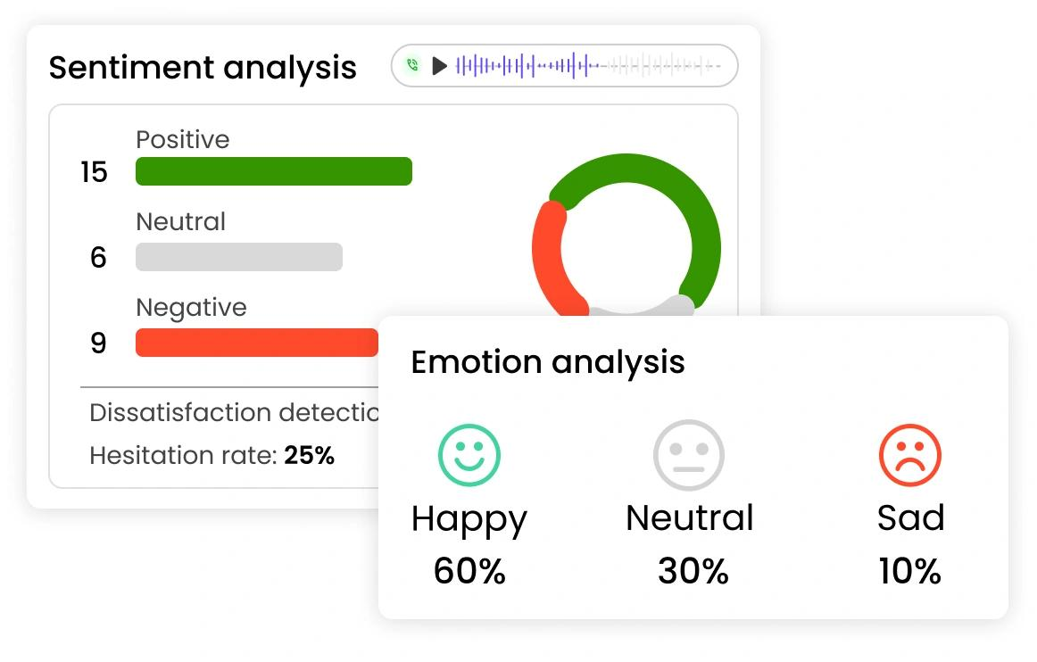
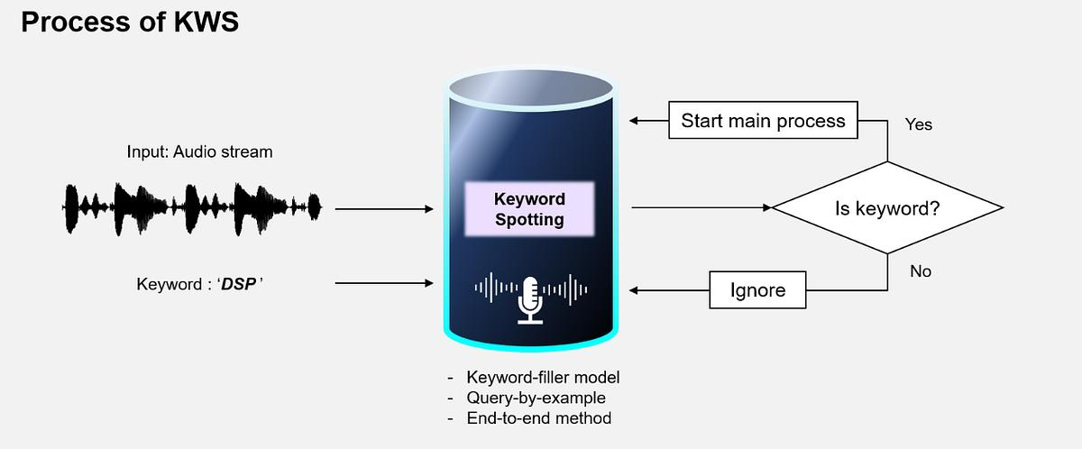
6
- Analyze conversations for:
  - Sentiment (positive/negative)
  - Key phrases
  - Issues detection
Helps businesses improve customer experience

9. Amazon Transcribe Medical
- Specialized for healthcare
- Converts doctor-patient conversations into structured notes
- Supports medical terminology

Architecture / Workflow (Conceptual)
Typical workflow:
- Store audio in Amazon S3
- Trigger transcription via API
- Process using AI models
- Store output in S3 or database

Pricing (Detailed)
- Pay-as-you-go model
- Charged based on audio duration
Example:
- ~$0.024 per minute (standard)
- Billed per second (minimum 15 seconds)
Free Tier:
- 60 minutes/month (first 12 months)
Cost depends on:
- Audio length
- Features used (analytics, medical, etc.)

Real-World Use Cases
Media & Entertainment
- Subtitle generation
- Video captioning

Call Centers
- Customer support analysis
- Quality monitoring

Healthcare
- Clinical documentation
- Voice-based patient records

Education
- Lecture transcription
- Accessibility for hearing-impaired students

Business
- Meeting notes automation
- Voice-based documentation

Advantages
- Fully managed (no infrastructure needed)
- High scalability
- Good accuracy (especially with clear audio)
- Easy integration with AWS ecosystem

Limitations
- Accuracy affected by:
  - Noise
  - Strong accents
- Cost increases with heavy usage
- Requires AWS knowledge for setup

Integration with Other AWS Services
Works well with:
- Amazon S3 → store audio
- Amazon Comprehend → sentiment analysis
- Amazon Translate → multilingual output
Summary (Perfect for HR Round)
Amazon Transcribe is a fully managed AWS AI service that converts speech into text using machine learning. It supports real-time and batch transcription, speaker identification, custom vocabulary, and advanced analytics, making it useful for applications like call centers, healthcare, media, and business automation.

Amazon Kendra
Find answers faster with intelligent enterprise search powered by machine learning
What is Amazon Kendra?
Receive highly accurate answers with an easy-to-use enterprise search service powered by Machine Learning (ML).
Implement a unified search experience quickly across multiple structured and unstructured content repositories.
Use natural language processing (NLP) to get highly accurate answers without the need for machine learning (ML) expertise.
Fine-tune your search results based on content attributes, freshness, user behavior, and more.


Use Cases
Enhance internal search experiences
Improve employee productivity and unlock the insights employees need to make data-driven business decisions through a single search interface.
Improve customer interactions
Reduce contact center costs with intuitive self-service bots, agent-assist solutions, and frictionless document access.

Integrate search into SaaS applications
Helps you find information faster with ML-powered in-app searches.

🔍 What is Amazon Kendra?
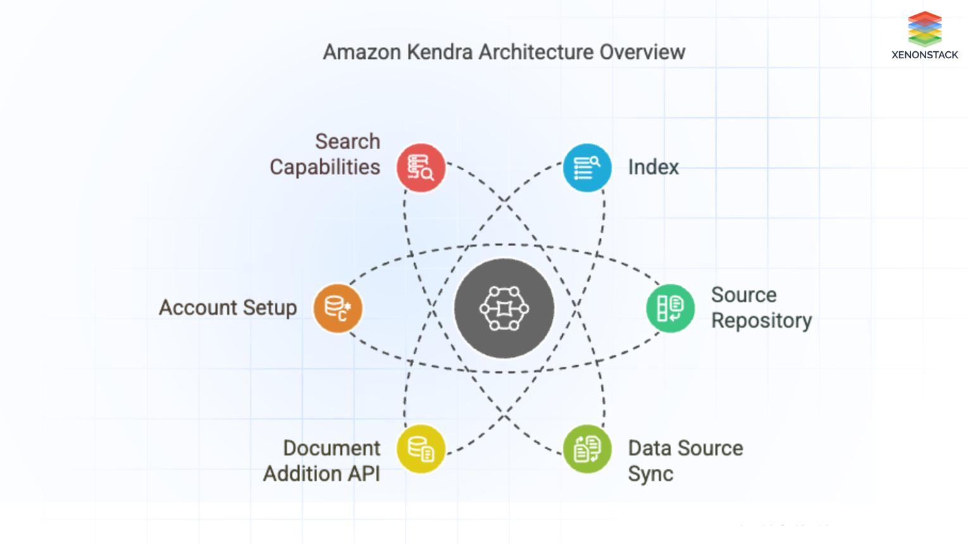
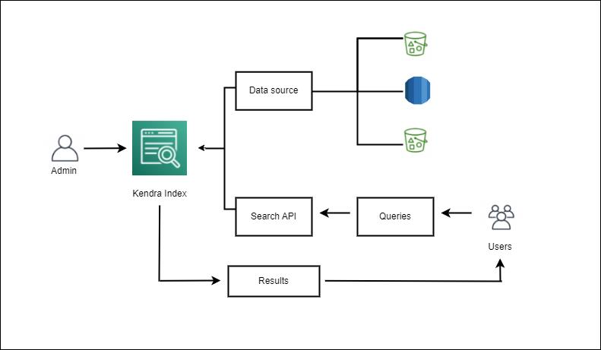
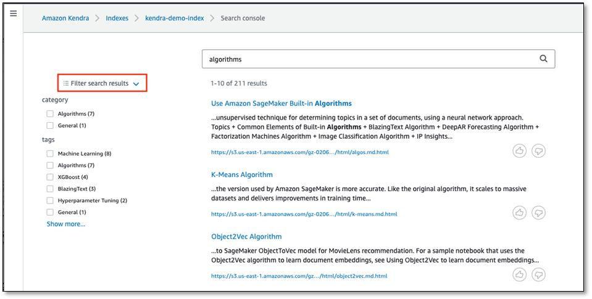
Amazon Kendra is an intelligent enterprise search service provided by Amazon Web Services.
It uses Artificial Intelligence (AI) and Natural Language Processing (NLP) to help users search and retrieve accurate information from large volumes of data.
Unlike traditional keyword search, Kendra understands:
- Meaning of queries
- Context of questions
- Intent behind user input

1. Core Concept (How it Works)
Kendra is based on semantic search.
- Traditional search → matches keywords
- Kendra → understands meaning + intent
Example:
- Query: “How many leaves are allowed?”
- Kendra → understands HR policy context and gives exact answer (not just documents)

2. Key Features of Amazon Kendra
🔹 2.1 Natural Language Search
Users can ask questions in normal English.
Example:
- “What is the company leave policy?”
- “How to apply for reimbursement?”
✔ Kendra understands grammar, synonyms, and context.

🔹 2.2 Machine Learning Ranking
Kendra uses ML to:
- Rank the most relevant answers at the top
- Improve results over time
✔ Learns from:
- User clicks
- Search patterns

🔹 2.3 FAQ Matching
- You can upload FAQs
- Kendra directly matches user questions to answers
✔ Very useful for:
- HR systems
- Customer support portals

🔹 2.4 Document Understanding
Kendra extracts information from:
- PDFs
- Word files
- HTML pages
- Databases
✔ It doesn’t just search text—it understands document structure

🔹 2.5 Incremental Learning
- Continuously improves search accuracy
- Adapts to new data automatically

3. Data Sources (Connectors)
Kendra connects to multiple systems:
Common Connectors:
- Amazon S3
- SharePoint
- Salesforce
- Google Drive
- Databases & file systems
✔ It pulls data from these sources and indexes it.

4. Indexing Process
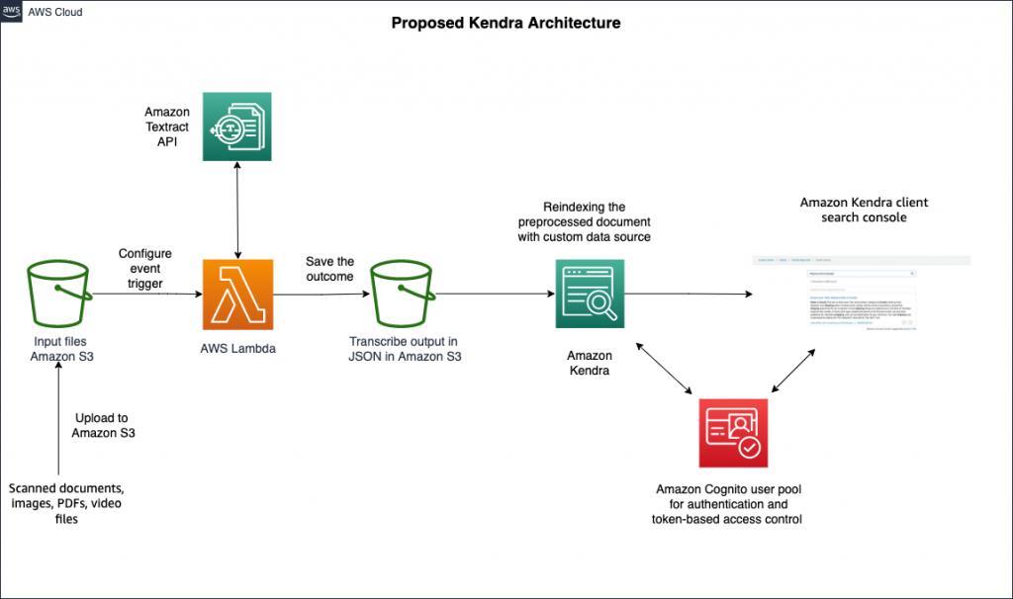


Steps:
- Data ingestion → Collect data from sources
- Parsing → Understand document structure
- Indexing → Store searchable representation
- Enrichment → Add metadata (tags, categories)
✔ Result → Fast and accurate search

5. Security & Access Control
- Integrates with IAM (Identity and Access Management)
- Supports document-level permissions
✔ Example:
- HR documents → only HR can see
- Finance reports → restricted access

6. Customization Features
🔸 6.1 Custom Relevance Tuning
- Boost certain documents
- Prioritize important content

🔸 6.2 Synonyms & Thesaurus
- “Leave” = “Vacation”
- “Salary” = “Compensation”
✔ Improves search accuracy

🔸 6.3 Custom Document Enrichment (CDE)
- Add metadata using Lambda functions
- Modify documents before indexing

7. Use Cases
🔹 Enterprise Search
- Internal company search engine
- HR, IT, policies, documents

🔹 Customer Support
- Chatbots
- Self-service portals

🔹 Knowledge Management
- Centralized knowledge base

🔹 AI Chatbots Integration
Works with:
- Amazon Lex
- Custom chatbots

8. Benefits
✔ Faster information retrieval
✔ Improved productivity
✔ Better decision making
✔ Reduced manual searching
✔ Enhanced user experience

9. Limitations
- Cost can be high for large data
- Needs proper data structuring
- Initial setup complexity

10. Kendra vs Traditional Search
Feature | Traditional Search | Amazon Kendra
Search Type | Keyword-based | AI-based
Accuracy | Low | High
Understanding | No context | Context-aware
Learning | Static | Dynamic ML

🧠 11. Architecture Overview
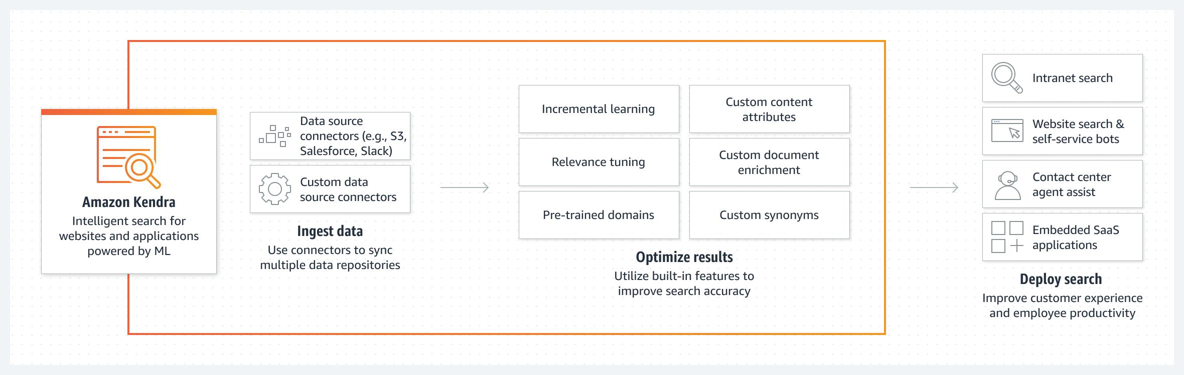
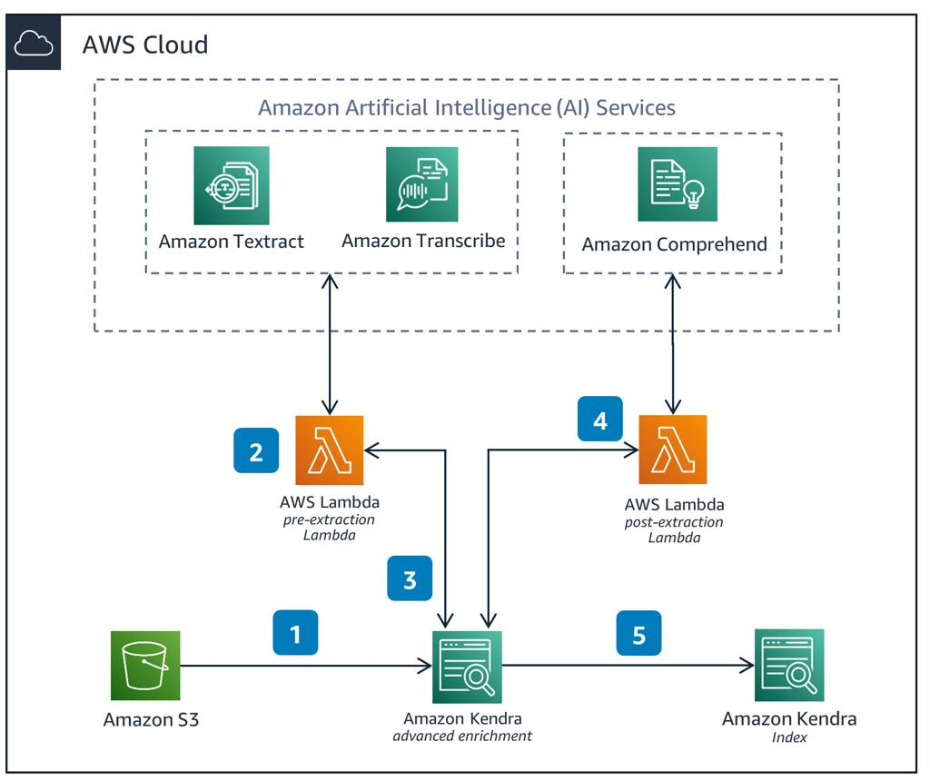

Main Components:
- Data Sources
- Index
- Query API
- Ranking Engine
- UI/Search Interface

12. Real Example
Scenario: HR Portal
Employee asks:
“How many sick leaves can I take?”
Kendra:
- Understands question
- Searches HR policy
- Returns exact answer

Final Summary
Amazon Kendra = AI-powered intelligent search engine
- Understands natural language
- Uses machine learning
- Connects multiple data sources
- Gives accurate answers (not just links)
How Amazon Kendra Works (Step-by-Step)




Think of Kendra like a smart brain for searching company data. It doesn’t just match words—it understands meaning, context, and intent.

Step 1: Data Ingestion (Collecting Data)
Kendra first collects data from different systems.
Sources include:
- Amazon S3
- SharePoint
- Salesforce
- Google Drive
What happens here:
- It connects using connectors
- Pulls documents like PDFs, emails, web pages
Example: HR policies, invoices, reports

Step 2: Document Parsing & Understanding
Once data is collected:
- Kendra reads the documents
- Extracts:
  - Text
  - Tables
  - Headings
  - Metadata
It understands structure like:
- Title
- Sections
- Important keywords
Not just reading—it’s understanding content

Step 3: Semantic Processing (AI Understanding)
This is the core intelligence part.
Kendra uses:
- Natural Language Processing (NLP)
- Machine Learning
What it does:
- Understands synonyms
(Leave = Vacation)
- Understands intent
(“apply leave” vs “leave balance”)
- Understands context
This is why it’s called semantic search

Step 4: Indexing (Building Search Engine Brain)
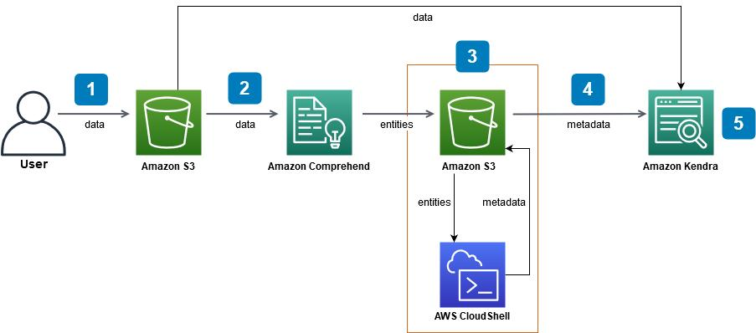

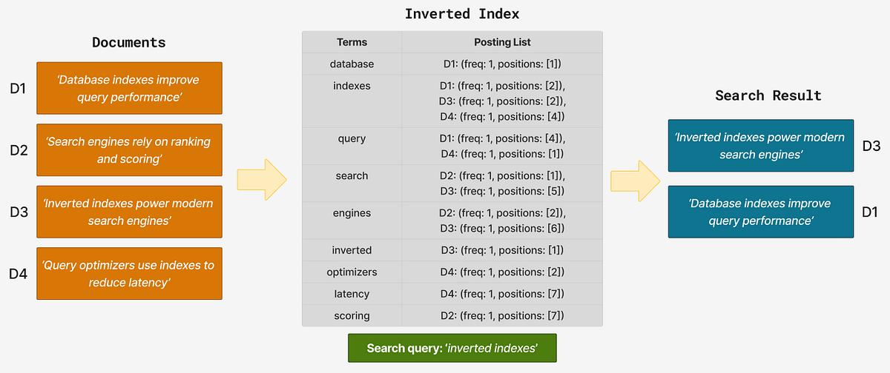

Kendra creates an index (like a smart database).
Inside the index:
- Processed document data
- Metadata (author, date, category)
- Relationships between words
This makes search:
- Fast
- Accurate

Step 5: User Query Input
User asks a question:
Example:
“How many paid leaves do I get?”

Step 6: Query Understanding
Kendra:
- Breaks the query into meaning
- Identifies:
  - Intent
  - Keywords
  - Context
It understands:
- “paid leaves” = HR policy
- “how many” = numeric answer

Step 7: Search & Matching
Now Kendra:
- Searches inside the index
- Matches:
  - Meaning (not just words)
  - Context
Even if document says:
“Employees are entitled to 20 annual leaves”
It still matches correctly.

Step 8: Ranking Results (ML-Based)
Kendra ranks results using Machine Learning:
Factors:
- Relevance
- Popularity
- User behavior
Best answer appears at the top

Step 9: Result Presentation

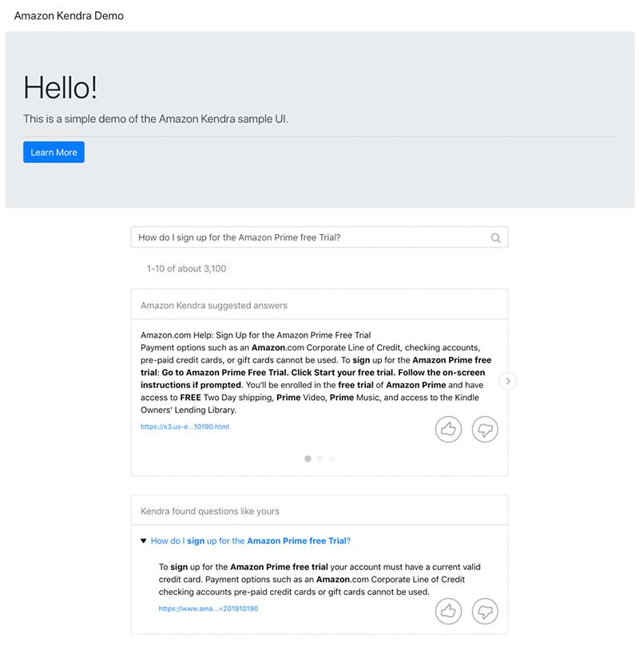
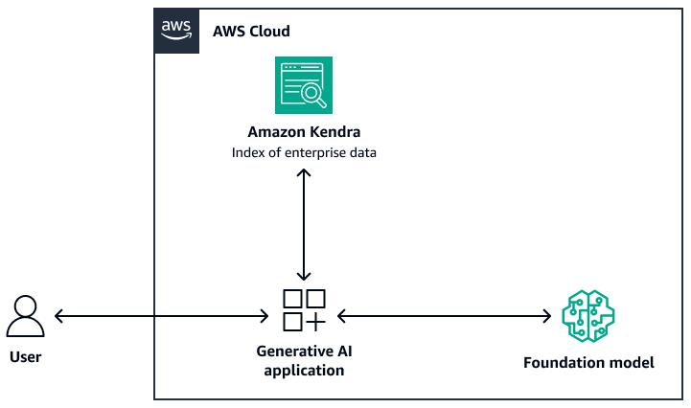

Kendra shows:
- Direct answers
- Highlighted text
- Relevant documents
Example output:
“Employees get 20 paid leaves per year”
No need to open full document

Step 10: Security Filtering
Before showing results:
- Checks user permissions
- Ensures:
  - Only authorized data is visible
Example:
- HR data → only HR users

Step 11: Continuous Learning
Kendra improves over time:
- Tracks user clicks
- Learns behavior
- Adjusts ranking
Makes search smarter daily

Full Working Flow (Simple Summary)
- Collect data
- Understand documents
- Process with AI
- Create index
- User asks question
- Understand query
- Search + match
- Rank results
- Show best answer
- Learn & improve

Real-Life Example (HR System)
User asks:
“What is maternity leave policy?”
Kendra:
- Understands HR context
- Searches indexed documents
- Finds exact section
- Shows direct answer

Final Understanding
Amazon Kendra works like a human expert search assistant
- Reads and understands documents
- Understands user questions
- Gives exact answers
- Learns continuously

